**Achievement Standard: 91046_1.3A**

Use design ideas to produce a conceptual design for an outcome to address a brief

**STUDENT PLANNING EVIDENCE**

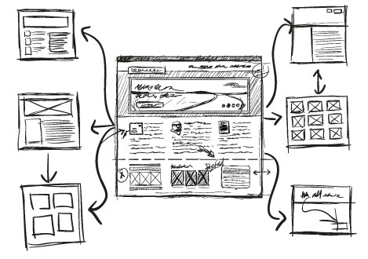

**STUDENT NAME:** Matthew King

Hand In Date: _____ / _____ / 2018

STAKEHOLDER MEETING 1

**MEETING DATE**: 6/09/18

**STAKEHOLDER:** Erin Hudson

|  |  |
| --- | --- |
| **DEVELOPER QUESTIONS** | **STAKEHOLDER RESPONSE / NEEDS** |
| Do you have a particular colour scheme in mind? | Nice pastel colours, not overloading. |
| Is there a particular style you would like to have the website to have? | Minimalistic and organic |
| What foods would you like on the website? | Thai beef salad. Prawns in Marie-rose. Pan seared Monkfish |
| Are there any specific photos you want to include? | Yes, I would like to use my own photos for the food and the logo should be from pixabay. |
| What would you like the title of the website to be? | Food Reviews and Recipes |
| Are there any particular fonts you want the website to use? | ‘Open sans’ for the body and ‘Kavivanar’ for the header |

**DECISIONS MADE AS A RESULT OF STAKEHOLDER MEETING 1**

|  |  |  |  |
| --- | --- | --- | --- |
| **STAKEHOLDER NEEDS** | **ATTRIBUTE** | **Physical / Functional** | **DEVELOPER DECISIONS** |
| Minimalistic and organic design | Aesthetic design | physical | I will avoid bright colours and large fonts. I will stick to 2 or 3 colours only and try and round the edges of my border and use circles instead of squares to provide a more organic looking design |
| Specific foods and photos on the website | Site content | Functional | I will use the foods the stake holder requested as well as their photos. I’ve given the stakeholder my email so she can email me the photos she wishes to use as well as any links to photos on Pixabay that she thinks may be appropriate. |

CONCEPT DESIGN 1 : Mind Map

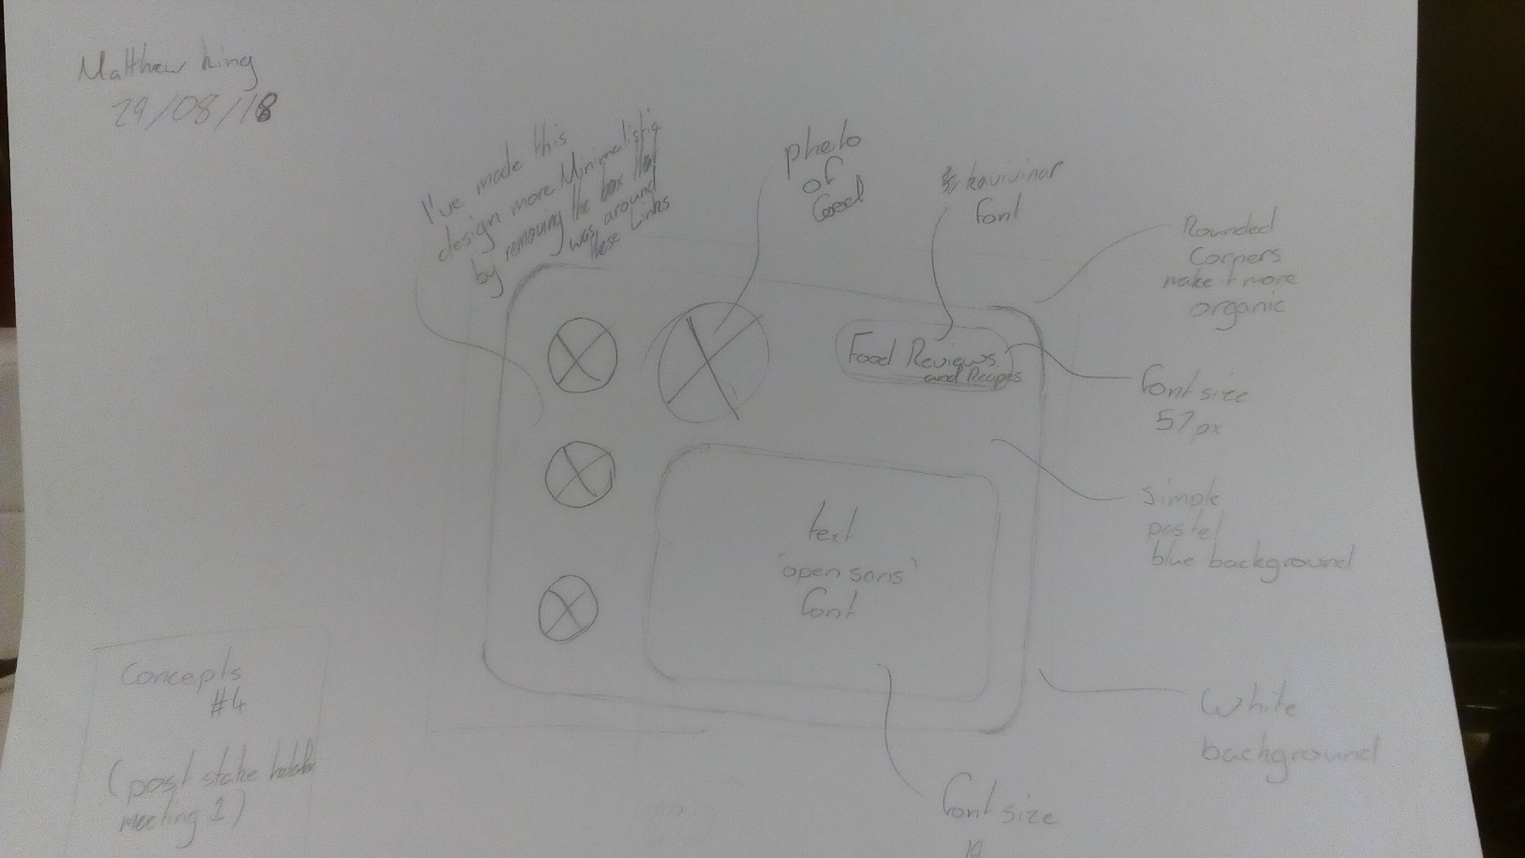

WEBSITE FEATURE RESEARCH

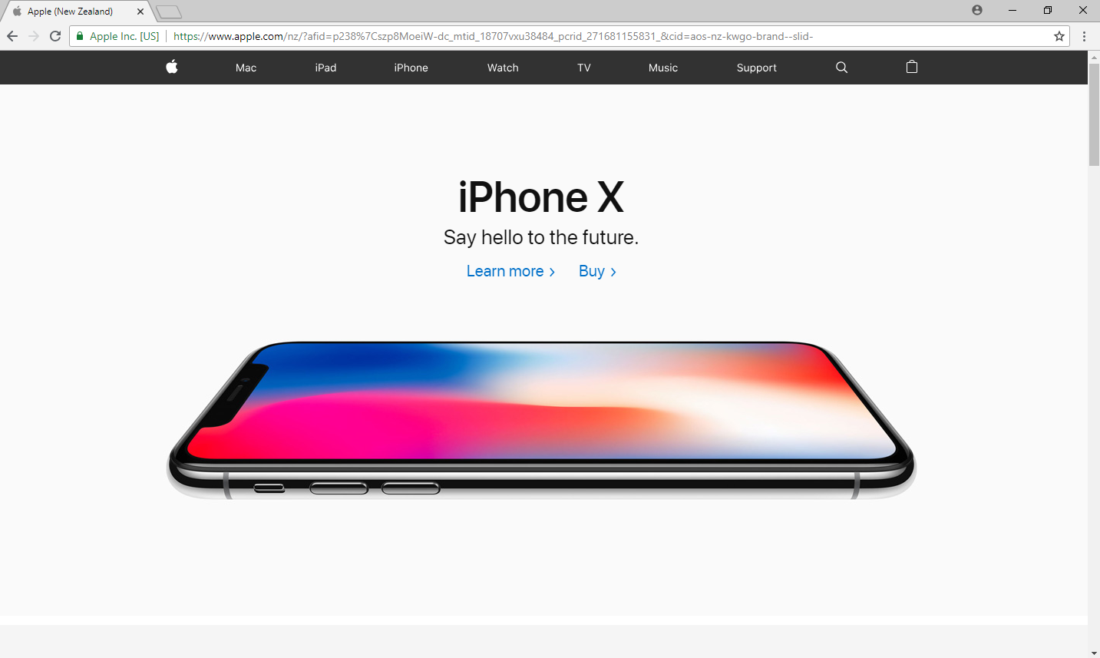

|  |  |  |
| --- | --- | --- |
| WEBSITE 1 : https://www.apple.com/nz/\ | | |
| WHAT I LIKE:  Minimalistic design  AND WHY | WHAT I DON’T LIKE  AND WHY | WHAT I CAN USE FROM THIS |
| * Simple easy to read font * Crisp white background makes it easy to read * The big photo is eye catching and enticing * The site has very little text but is still easy to understand | -It seems a bit soulless and lacks warmth which is probably not good for a food website | - keep text simple on the home page, direct users towards the food pages  - Large photos that catch the user’s eye are good |

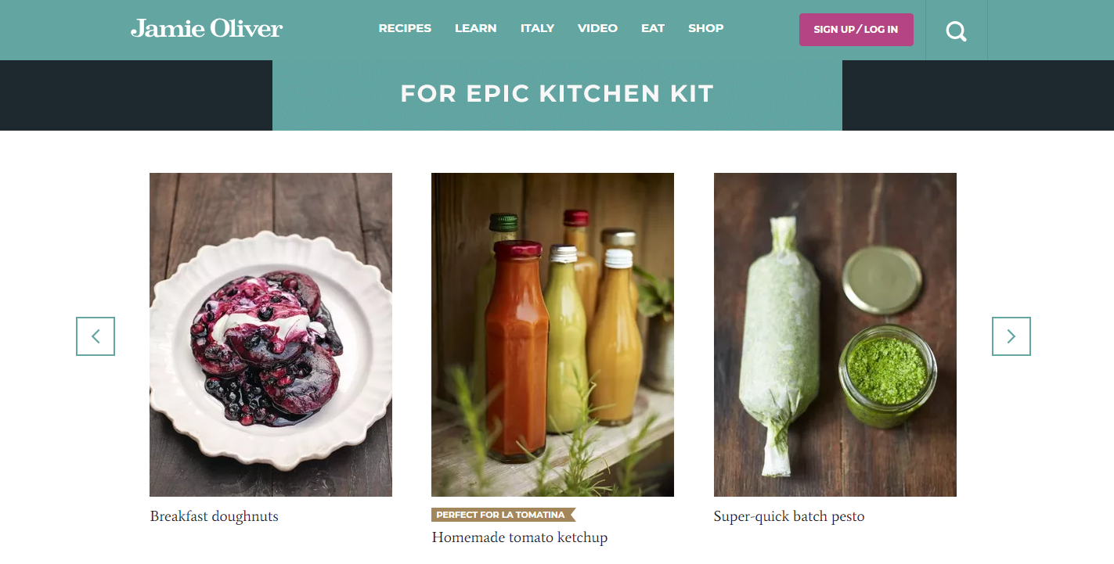

|  |  |  |
| --- | --- | --- |
| WEBSITE 2: <https://www.jamieoliver.com\> | | |
| WHAT I LIKE  AND WHY | WHAT I DON’T LIKE  AND WHY | WHAT I CAN USE FROM THIS |
| * Large photos are eye catching but simple. This entices a user without overloading them which is what I want to do for Erin’s site. * The page is simple, utilising a 2-colour pallet that suits the site. This is good for the minimalistic design I’m trying to create | * The advert up the top of the page is annoying and poorly done (the black sides look bad) | * Keep the colour pallete to 2 or 3 simple colours. * A White background is better than a coloured one * I should have all my images in the center of the mage |

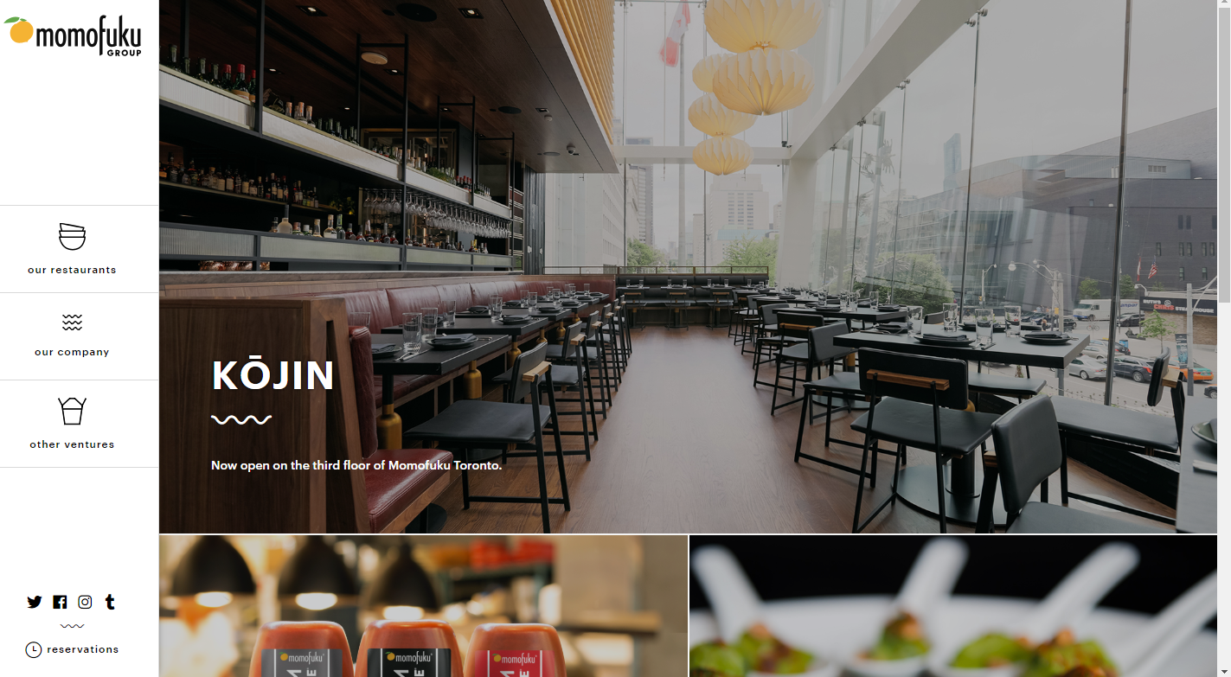

|  |  |  |
| --- | --- | --- |
| WEBSITE 3: https://momofuku.com/ | | |
| WHAT I LIKE  AND WHY | WHAT I DON’T LIKE  AND WHY | WHAT I CAN USE FROM THIS |
| * Large photos grab the eye and entice the user * The images have lots of colour, so no background colours are needed. This is very minimalistic which is what my client wants. | * The images are a bit overwhelming at first. * The navigation options on the left hand are not very specific | * Make sure to not make the images too large or overpowering * Make sure the navigation options are simple and easy to understand |

Website Feature DECISIONS MADE AS A RESULT OF MEETING 2

|  |  |  |
| --- | --- | --- |
| CHOSEN LAYOUT | STAKEHOLDER COMMENTS | DECISIONS AS A RESULT OF CHOICE |
| Website 3 | * The images are clear and elegant * Minimal amount of text is used * Menu/navigation is clearly labelled and easy to recognise * They have well utilized their space with images, but this does not overload the user | * Use elegant images * Limit the amount of text on the page (except for the review pats) * Have the navigation bar and logo on left hand side of website |

WEBSITE LAYOUT RESEARCH

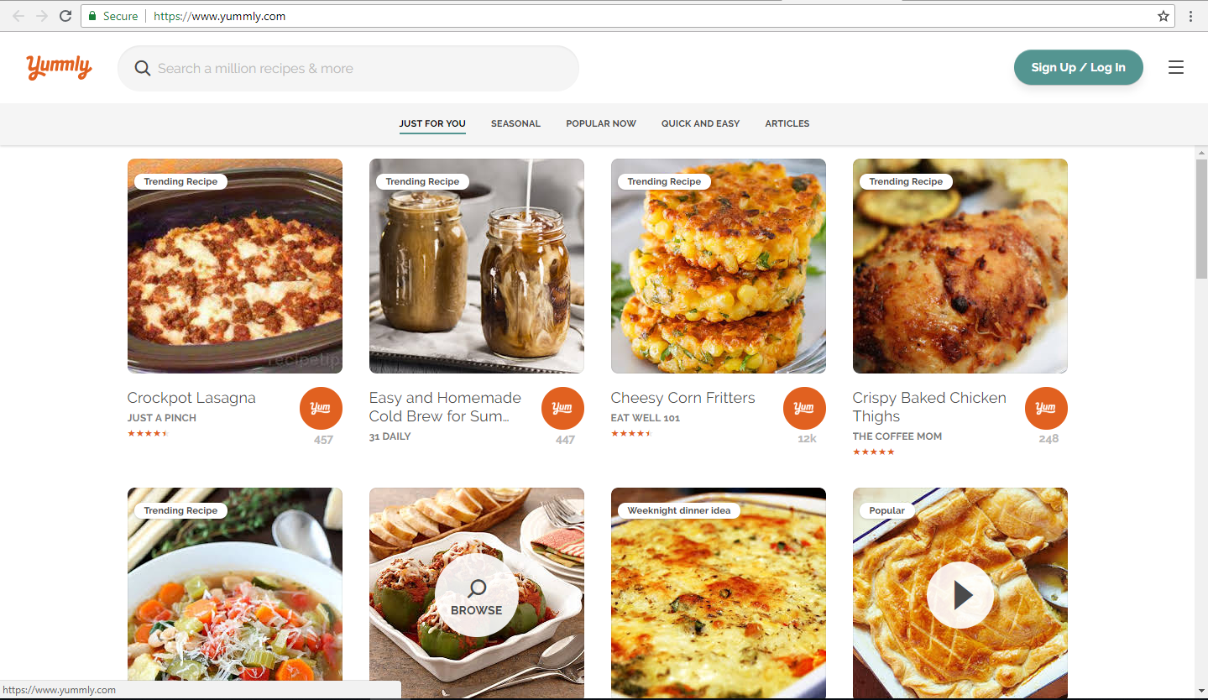

logo

Search bar

Blank space

Login/signup

Navigation bar

Link as image

Link as image

Link as image

Link as image

Name of food

Website it’s from

rating

Name of food

Website it’s from

rating

Name of food

Website it’s from

rating

Name of food

Website it’s from

rating

|  |  |  |
| --- | --- | --- |
| WEBSITE 1 : [https://www.yummly.com](https://www.yummly.com/) | | |
| WHAT I LIKE  AND WHY | WHAT I DON’T LIKE  AND WHY | WHAT I CAN USE FROM THIS |
| * Large photos catch the eye * Simple design is easy to understand and use * The font is nice. Its: easy to read, eye catching and it suits the ‘food theme’ | * The distance between photos is not the same as the distance between the photos and the border. * The logo is too small | * The idea of large images with rounded edges * The font |

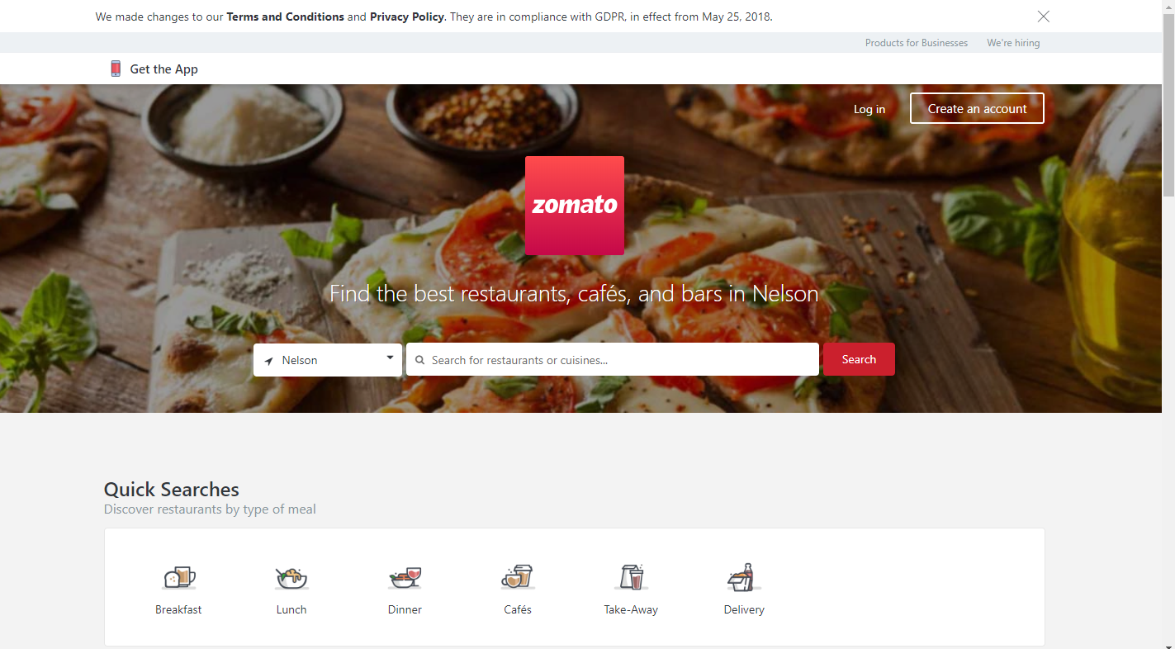

Grey background

Image as background

LOGO

Login | create account

Search bar

Quick search bar with images for easy navigation

|  |  |  |
| --- | --- | --- |
| WEBSITE 1 :www.zomato.com/nelson | | |
| WHAT I LIKE  AND WHY | WHAT I DON’T LIKE  AND WHY | WHAT I CAN USE FROM THIS |
| * It directs the user straight to want they are most likely to use (the quick search tool) * The logo is in front of and centred on their image. * Big bright image is eye catching | * The colourful background distracts the eye a bit | * The idea to use an image as a background for the logo (just make sure the image is not too bright) * The image fills the entire width of the screen, there is no margin |

Website Layout DECISIONS MADE AS A RESULT OF MEETING 2

|  |  |  |
| --- | --- | --- |
| CHOSEN LAYOUT | STAKEHOLDER COMMENTS | DECISIONS AS A RESULT OF CHOICE |
| Website Layout 1 – yummly | * This site layout utilised the given space well, while not overcrowding the screen * The simplistic colour of the site background lets the bright food images be the eye-catching point of the site * The navigation and search is nice and clear | * Use a ‘simplistic colour’. I will check with the stake holder to confirm any colour choices. * Make sure to use a minimalist design to avoid overcrowding the screen |

COLOUR RESEARCH

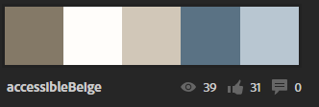

|  |  |  |
| --- | --- | --- |
| WHAT I LIKE  AND WHY | WHAT I DON’T LIKE  AND WHY | WHAT I CAN USE FROM THIS |
| -simple  -not too bright | -bland  -not pastel (stake holder wanted pastel) | - don’t use bland colours for a food website  - use 1 or 2 colours max (just use shades of those colours instead) |

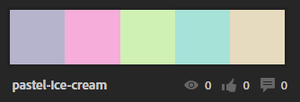

|  |  |  |
| --- | --- | --- |
| WHAT I LIKE  AND WHY | WHAT I DON’T LIKE  AND WHY | WHAT I CAN USE FROM THIS |
| * The stake holder likes it (it’s pastel) * Its has a food theme (its called pastel-ice-cream after all) * It has subtle colours that won’t hide/blur text (good for backgrounds) * It has nice bright colours (good for borders/ margins) | * It may not match the food. These colours would not go with pizza | * The pale colours that are great for background on text, especially the beige |

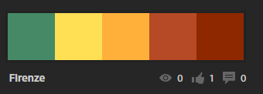

|  |  |  |
| --- | --- | --- |
| WHAT I LIKE  AND WHY | WHAT I DON’T LIKE  AND WHY | WHAT I CAN USE FROM THIS |
| * The colours are very Mexican (which suits the foods) * They are bright and joyful and eye catching (great for some areas of a food website) | * None of the colours are good for backgrounds on text * There isn’t a white or cream colour to compliment this pallete that would be good for text | * The bright colours are good for backgrounds or outlining images. However, they would not work for text. * I must be careful to use only a couple bright colours. Otherwise the colour pallet will distract from the website and make it look unprofessional |

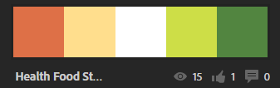

|  |  |  |
| --- | --- | --- |
| WHAT I LIKE  AND WHY | WHAT I DON’T LIKE  AND WHY | WHAT I CAN USE FROM THIS |
| * The light green promotes a healthy look and would suit the website well * The white could be useful to make the website look clean and modern. | * The dark green and brown wouldn’t suit the website. * The plain white is too hard on the eyes, a smooth cream would be much better | * I must be careful to choose a white that looks clean. But is not too hard on the eyes. I want the website to feel warm, not sterile. |

Colour DECISIONS MADE AS A RESULT OF MEETING 2

|  |  |  |
| --- | --- | --- |
| CHOSEN LAYOUT | STAKEHOLDER COMMENTS | DECISIONS AS A RESULT OF CHOICE |
| Colour swatch 2:  pastel-ice-cream | * The colours are bright and welcoming * It fits the food theme of the website, considering it is an ice-cream palate * It will be good to use as a background as dark fonts will stand out from it clearly | * Make the colours ‘bright and welcoming’ * Keep the colours centred around food * Keep the final colour pallet light so that dark fonts will stand out |

FONT RESEARCH

**FONT 1 :** Montserrat

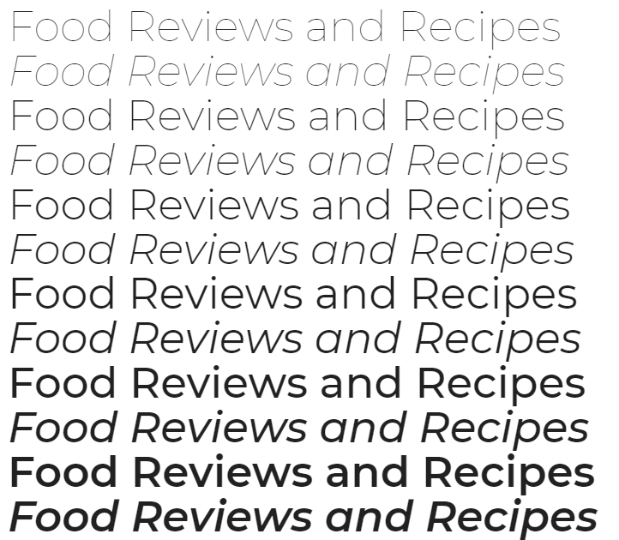

|  |  |  |
| --- | --- | --- |
| WHAT I LIKE  AND WHY | WHAT I DON’T LIKE  AND WHY | WHAT I CAN USE FROM THIS |
| * Nice and clean font * Clear and easy to read * The bottom line looks good (the italics look nice in this font) | * In small font sizes, it becomes a bit hard to see. Because it is too thin * It looks a bit basic | * Make sure to not use a font that’s too thin, it may disappear into the pastel colour scheme |

**FONT 2 :** Noto serif JP

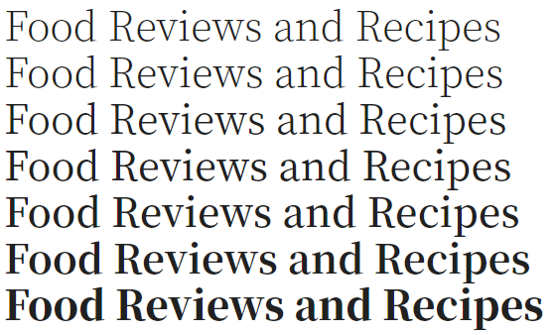

|  |  |  |
| --- | --- | --- |
| WHAT I LIKE  AND WHY | WHAT I DON’T LIKE  AND WHY | WHAT I CAN USE FROM THIS |
| * The font looks good and is easy too read even in its smallest form * It looks professional * It is clean | * It seems to blocky * The serifs distract the eye * The largest font is too fat | * Don’t make the font too fat at large sizes * Don’t make it too boxy (it doesn’t suit the food theme) * Don’t use serifs |

**FONT 3 :** Source Sans Pro

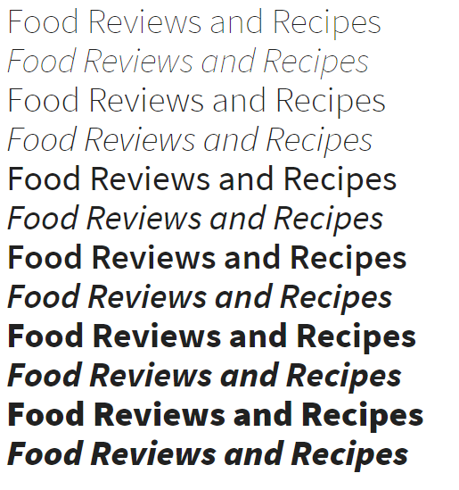

|  |  |  |
| --- | --- | --- |
| WHAT I LIKE  AND WHY | WHAT I DON’T LIKE  AND WHY | WHAT I CAN USE FROM THIS |
| * It has a bunch of different styles. This means I can use one font for most of the website and just use different styles for headers, text etc. | * The font looks fat at large sizes * It doesn’t flow nicely (The letters don’t join nicely and are hard to read) | * The style at the top looks nice. It looks similar to apple’s font. It would suit a modern or minimalistic website |

**FONT 4 :** Gamja Flower



|  |  |  |
| --- | --- | --- |
| WHAT I LIKE  AND WHY | WHAT I DON’T LIKE  AND WHY | WHAT I CAN USE FROM THIS |
| * It has a nice handwritten style which is warm and welcoming. This suits a food website. * Even though it has a handwritten style, it is still easy to read | * It would only suit titles and banners. And because it doesn’t have any other styles it would require an entirely different font for body text | * When choosing a font for titles. It should have an accompanying font/style for body text |

**FONT 5 : Ruslan display**



|  |  |  |
| --- | --- | --- |
| WHAT I LIKE  AND WHY | WHAT I DON’T LIKE  AND WHY | WHAT I CAN USE FROM THIS |
| * It has all caps which makes it great for titles | * It is hard to read * It is far too blocky for a food website * It doesn’t suit the style of the website | * Don’t use an all caps font * Use nice and flowy fonts |

**FONT 6 :** Libre Barcode 128 Text

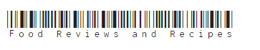

|  |  |  |
| --- | --- | --- |
| WHAT I LIKE  AND WHY | WHAT I DON’T LIKE  AND WHY | WHAT I CAN USE FROM THIS |
| * It looks cool * It’s a pun because food products also have barcodes (- stake holder) * The font is easy to read? | * It is useless * The barcode makes the font hard too read * The font is probably not website friendly | * Don’t use fonts with silly glyphs * Make sure the font is website safe |

Font DECISIONS MADE AS A RESULT OF MEETING 2

|  |  |  |
| --- | --- | --- |
| CHOSEN LAYOUT | STAKEHOLDER COMMENTS | DECISIONS AS A RESULT OF CHOICE |
| Source Sans Pro | * This font in nice and neat, which makes it look more professional * The letters are clearly readable * The many different styles this means it can be used for multiple different headings, making in very flexible | * Use a font with lots of different styles so it can be used in multiple different styles for different headings * Use a professional looking font (like this one) |

NAVIGATION BAR RESEARCH

**NAVIGATION BAR 1**



<https://www.jbhifi.co.nz/>

|  |  |  |
| --- | --- | --- |
| WHAT I LIKE  AND WHY | WHAT I DON’T LIKE  AND WHY | WHAT I CAN USE FROM THIS |
| * The white text contrasts nicely with the black background * The links are well labelled so the user knows exactly what they’re clicking on and it also makes it easy for the user too find what they are looking for. | * It doesn’t contrast without the black image behind it. * The width of each button is uneven | * Make sure the navigation bar contrasts with the other element of the website to make sure it is clearly visible |

**NAVIGATION BAR 2**



|  |  |  |
| --- | --- | --- |
| WHAT I LIKE  AND WHY | WHAT I DON’T LIKE  AND WHY | WHAT I CAN USE FROM THIS |
| * It is simple and clean looking. The font colour contrasts the background nicely * The navigation links are grouped based on similarity (things related to logging in and purchasing an account are grouped away from the rest of the links) | * The buttons are not well defined, and it can be hard to tell where their borders are. | * It is okay to have a nav bar that does not contrast at all with the background, as long as the navigation buttons are well defined. * Make sure to group nav links that are related together to improve the websites efficiency. |

**NAVIGATION BAR 3**

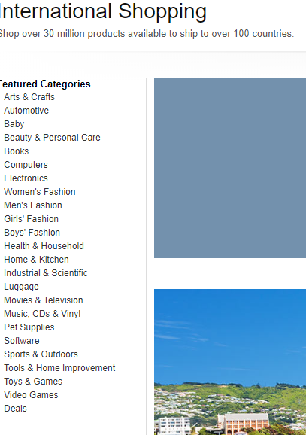

|  |  |  |
| --- | --- | --- |
| WHAT I LIKE  AND WHY | WHAT I DON’T LIKE  AND WHY | WHAT I CAN USE FROM THIS |
| * The font suits it, it is easy to read even in small size. | * It is super cluttered. It is confusing to the eye at first glance and it is hard to find what you are looking for * The border of the buttons are not well defined, this means it is hard to tell where to click to access each link. * It is not clear whether these are links or if they are just search recommendations | * Make sure to keep the navigation bar simple and precise to avoid confusing or overcrowding the navigation bar |

**NAVIGATION BAR 4**



|  |  |  |
| --- | --- | --- |
| WHAT I LIKE  AND WHY | WHAT I DON’T LIKE  AND WHY | WHAT I CAN USE FROM THIS |
| * The buttons are well defined, so it is easy to see where to click | * It is super cluttered which makes it hard to find what you are looking for * The font is small (especially the top navigation bar) making it hard to read and hard to navigate | * Don’t overfill the bar or make the text too small to read * Light blue is a good background colour, it draws the eye without distracting the reader from the text. |

**NAVIGATION BAR 5**



|  |  |  |
| --- | --- | --- |
| WHAT I LIKE  AND WHY | WHAT I DON’T LIKE  AND WHY | WHAT I CAN USE FROM THIS |
| * The fonts are clear and easy to read. They contrast nicely with the background and are nice and large. * The labels on the navigation bar are precise yet simple. Making it easy to find your way around, without distracting the eye. * The button’s outlines appear when you hover over them. Making it clear where to click | * The drop-down menus are very cluttered and confusing. * It is not immediately clear what the ‘chat’ icon is for | * Hide lots of information under drop down boxes to reduce clutter on the main bar * Black background with white text is a good colour combo for nav bars |

**NAVIGATION BAR 6**



|  |  |  |
| --- | --- | --- |
| WHAT I LIKE  AND WHY | WHAT I DON’T LIKE  AND WHY | WHAT I CAN USE FROM THIS |
| * It is easy to see because it contrasts the background colour of the rest of the site * The buttons have both text and images making them easy to understand * The buttons have borders which makes it easy to see where to click | * The black text does not stand out enough against the green background * The search bar uses white text, but the nav buttons use black text | * Make sure all text is the same colour * Use both an image and text for nav buttons to give the user a clear idea as to where the button will take them |

Navigation Bar DECISIONS MADE AS A RESULT OF MEETING 2

|  |  |  |
| --- | --- | --- |
| CHOSEN NAVIGATION BAR | STAKEHOLDER COMMENTS | DECISIONS AS A RESULT OF CHOICE |
| Nav Bar 6 (wikihow) | * It is simplistic and neat * The buttons are immediately understandable and are grouped together away from the main logo. * The background colour suits the theme of the website, it is eye catching without distracting (too much) from the text. | * Use both text and photos on navigation buttons * Use a good background colour for the nav bar (make sure to consult the stake holder so she agrees on the colour) |

TEXT CONTENT FOR WEBSITE

* **Home:**

Home - Food Reviews and Recipes

This Page reviews different foods and provides recipes if you want to try any of these dishes at home. browse through the various sections for a brief preview of some of the foods we have reviewed.

All artwork used on this page is either Public Domain (via Pixabay) or the images have been takes by us.

Accessing recipes has never been easier if you have a device like an iPad / tablet, there are plenty of different food recipes and websites online.

Please use the sidebar to see some other good food review and cooking sites.

CC Erin Hudson 2018

* **Thai Beef Salad**

**Thai Beef Salad**

Season: **Best in summer and spring, but it can be a year-round dish**

Rating: **★★★★★**

**Thai Beef Salad - Recipe**

Tailor Farms Asian Chopped Salad as a base

Sauce:

-2 Tbsp sesame oil

-2 Tbsp soy sauce

-2 Tsp chopped garlic

-½ Tsp grated ginger

-¼ Tsp chilli paste

-1 Tsp palm sugar

-1 bag of trident crispy noodles original

Dissolve in pan together, adjust to taste. Cook off a handful of blanched peanuts in a pan with a little of the about sauce. Set aside to cool. Season rump or sirloin steak with salt & pepper and sear off on a high heat in the pan. Turn down temperature and pour in some sauce over meat. Remove meat from pan. Put salad into bowls and mix though nuts. Thinly slice beef and put on salad. Top with trident crispy noodles and add dressing from salad packet.

***Review***

*This summer delight includes pan-fried steak on a fresh Asian chopped salad with crispy noodles added in for a nice texture balance and a beautiful dressing that completes the dish. All of the elements work very well together and although the dish itself is quite filling it will leave your taste buds wanting more.*

*Not only is this dish wonderful to eat it is quite simple to make if you would like to try this dish for yourself just follow the recipe and enjoy!*

* Prawns in Marie-Rose

**Prawns in Marie-Rose**

Season: **Summer & Spring**

Rating: **★★★★★**

**Prawns in Marie-Rose - Recipe**

Defrost cooked prawns & have Iceberg lettuce for serving. Approx - 10 mins (After prawns are defrosted)

Sauce:

- 1 1/2 cup Master-foods Mayonnaise

- 1 Tbsp Tomato Ketchup

- 1 Tsp Brandy

- 3 Drops Worchester sauce

1. Whisk Sauce together

2. Put on top of prawns and lettuce

3. Sprinkle paprika on top.

***Review***

*This refreshing dish is great in nice weather with its fresh lettuce and delicious prawns, the sauce has a great tang that completes the dish, it can work as a starter or a full on main depending on the dish size. Not only is this dish a stunner but it is super simple to make, taking only 10 minutes after the prawns have defrosted.*

*If you would like to give the dish a try, just follow the recipe.*

-***Pan Seared Monk Fish***

**Pan Seared Monkfish**

Season: **Autumn & Winter, but it can be a year-round dish**

Rating: **★★★★**

**Review**

**Pan Seared Monkfish**

-600g monkfish fillet

-2 Tbsp oil

-4 cloves of garlic

-Sea salt & freshly ground black pepper

Cut monkfish fillet in four regular pieces. Season monkfish fillets with salt and pepper. Heat oil in a pan on medium-high. Add monkfish and garlic. Turn over monkfish when seared side has tuned paper bag brown. The fish should stay glassy inside, so do not sear too long

Plate with mash and crisped pancetta, chive oil, caramelized Garlic and shallots.

**Review**

*This warming fish dish is great when its cold outside, but it is also very versatile and can work on any day of the year. The tanginess of the pancetta with the monkfish is an explosion of flavour that will leave you wanting more. Although this dish does take more effort and time to make it's well worth it for the end result.*

*If you would like to try making this dish just follow the recipe.*

* ***Contact Us***

*Hope you enjoyed reading our reviews, why not try making some of the dishes yourself. For many more dishes to try visit some of the sites we have on the home page.*

*If you would like to contact us for any reason just fill in the contact sheet, send it in and we will get back to you as soon as we can.*

Text Content DECISIONS MADE AS A RESULT OF MEETING 2

|  |  |  |
| --- | --- | --- |
| WHAT I LIKE  AND WHY | WHAT I DON’T LIKE  AND WHY | WHAT I CAN USE FROM THIS |
| * It has both recipes and reviews * The stake holder supplied it so I know it’s exactly what she wants * there are no grammatical or spelling errors * The content includes star ratings, which is far better than writing ‘five stars’ etc | * The recipes don’t include instructions * There is not a lot of indication as to what the stake holder wants for nav bar contents or title content | * The text and simple recipes * The ratings |

WEBSITE BACKGROUNDS RESEARCH

<https://www.lahautesociete.com/>

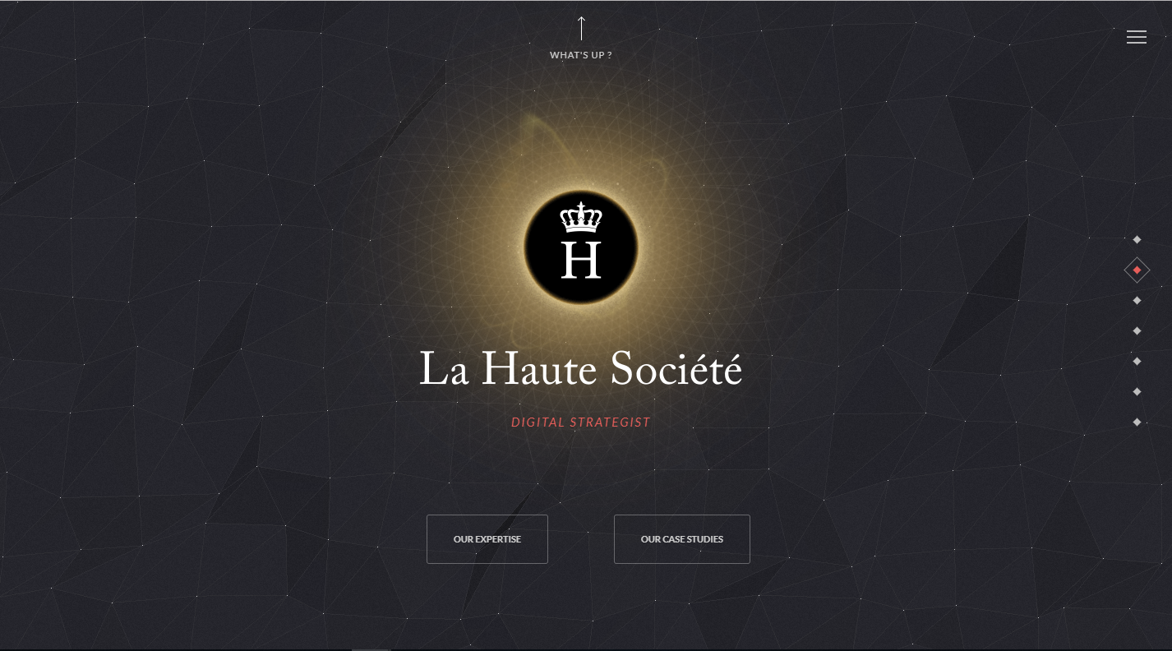

|  |  |  |
| --- | --- | --- |
| WHAT I LIKE  AND WHY | WHAT I DON’T LIKE  AND WHY | WHAT I CAN USE FROM THIS |
| * The animated background catches the user’s eye and provokes interest. * It uses geometrical patterns to create a minimalistic design that does not feel bland or empty unlike many other websites with minimalistic designs * The yellow backlighting behind the website’s logo is amazing. It creates a great feeling of warmth even though the rest o the site has a dark colour scheme | * The background causes the navigation bar to become almost invisible because the two are so similar. | 1. Geometric backgrounds can look awesome with some simple JavaScript animation if they suit the website. However be careful because otherwise the design will obscure parts of the website because of camouflage. |

<https://activetheory.net/lab>

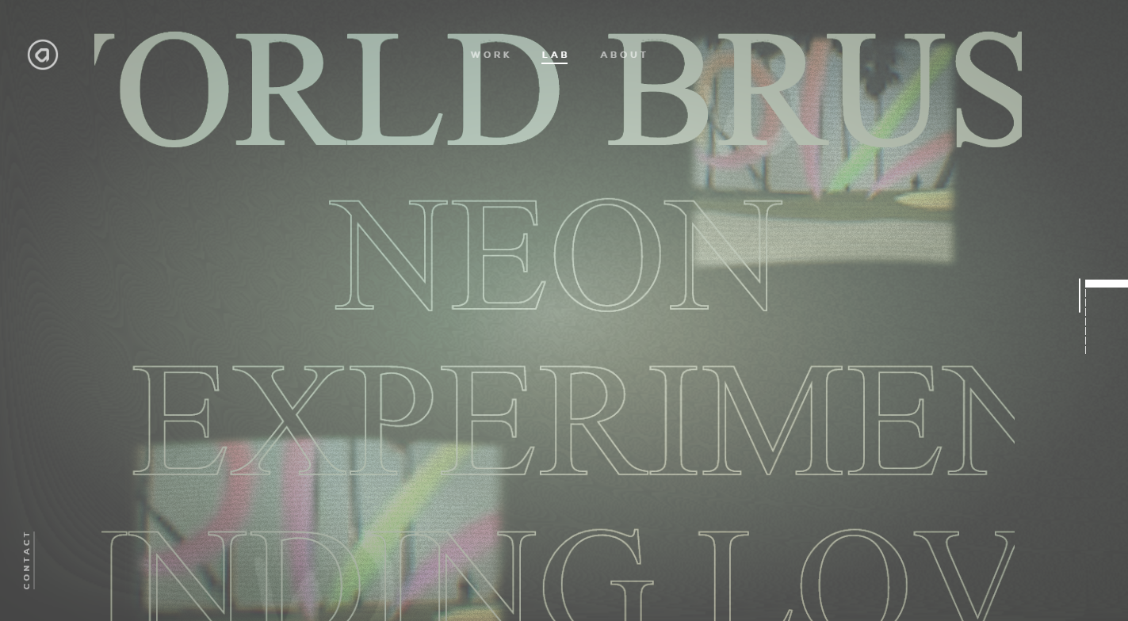

|  |  |  |
| --- | --- | --- |
| WHAT I LIKE  AND WHY | WHAT I DON’T LIKE  AND WHY | WHAT I CAN USE FROM THIS |
| * The gradient colour scheme and washed out appearance suits the site well and is an innovative use of colour. * The background responds to user input (the text moves when you scroll the mouse) * The background is dark on the outside but light on the inside, this gradient draws the user’s eye towards the middle of the screen (the important bit) | * The background obscures the websites navigation features. | -maybe I could use a graduated background in order to draw the user towards certain features i.e. the navigation icons or something like that. |

<http://www.nurturedigital.com/>

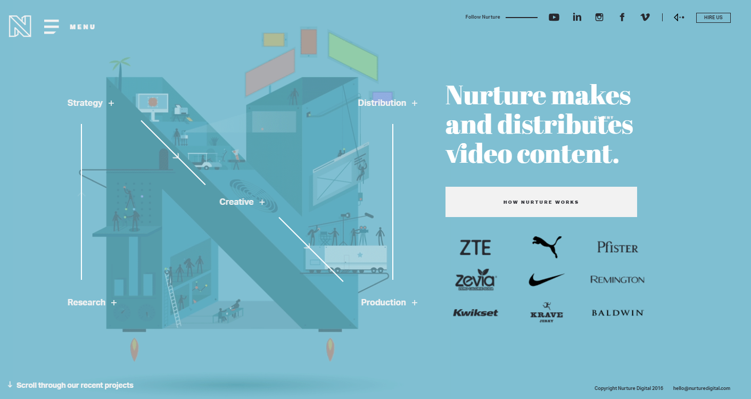

|  |  |  |
| --- | --- | --- |
| WHAT I LIKE  AND WHY | WHAT I DON’T LIKE  AND WHY | WHAT I CAN USE FROM THIS |
| -it is an awesome blue (it has a gradient from the bottom to the top.) Also, the N shape is animated and suits the company.  -This animation catches the user’s eye, and because it relates very well to what the company is about, a user is able to understand the company without having to read lots of text. | - It would not work well for what my client wants. This style of background would only work if the client had very little text on their page, however because the client wants to show lots of text on the site, the use of an animated image as a background is impractical. | - an animated image is not a good choice for the client’s website because the clients website does not have enough space to use one effectively. |

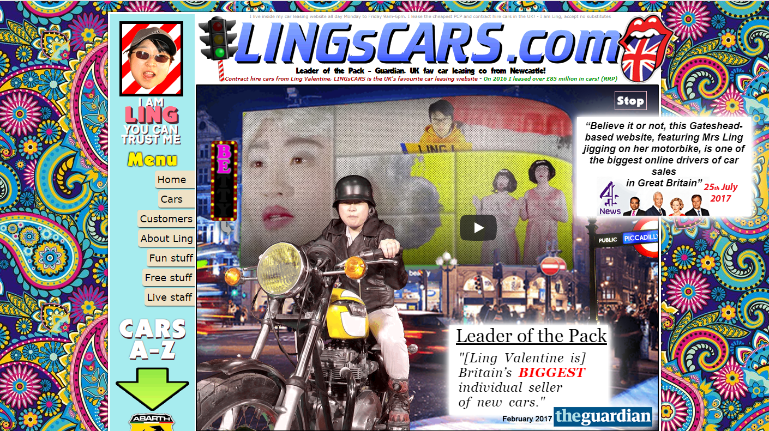

|  |  |  |
| --- | --- | --- |
| WHAT I LIKE  AND WHY | WHAT I DON’T LIKE  AND WHY | WHAT I CAN USE FROM THIS |
|  | * It is an epileptic nightmare * The background does not suit the site (but then again, what does?) * This site is so awful it is physically painful to look at. * Because of the sites poor design, I cannot take anything within the site seriously. * I definitely will not be buying any of my cars from ling, as I do not trust him. | * Nothing, just nothing |

<https://www.pennyjuice.com/childcare-juice-concentrates>

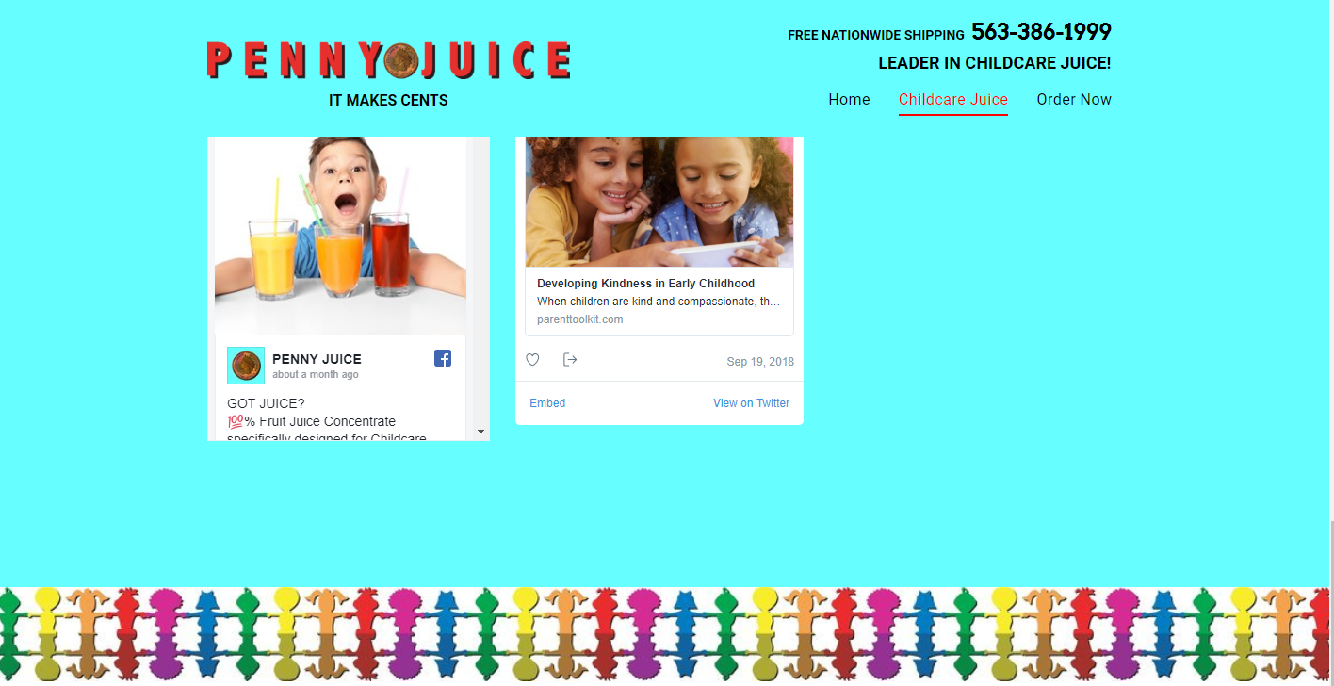

|  |  |  |
| --- | --- | --- |
| WHAT I LIKE  AND WHY | WHAT I DON’T LIKE  AND WHY | WHAT I CAN USE FROM THIS |
| * It’s clearly a kid’s site (it was obviously designed by them) * It has a pun (which accurately represents their quarterly earnings) | * The blue looks like toxic waste * The border is confusing and painful   It is so plainly blue, the user doesn’t know where to look | * Don’t use a solid block of background colour * Don’t use advice from 4-year olds * Don’t use a border. |

Website Background DECISIONS MADE AS A RESULT OF MEETING 2

|  |  |  |
| --- | --- | --- |
| CHOSEN BACKGROUND | STAKEHOLDER COMMENTS | DECISIONS AS A RESULT OF CHOICE |
| Nuture digital(background 3) |  |  |

IMAGE CREATION and MANIPULATION

On this page(s) you will show your original images + the finished images after manipulation + describe and illustrate what you did to manipulate the images FOR TWO IMAGES ONLY.

NOTE – the Finished Image must be smaller in both file size and dimensions otherwise the manipulation has not been effective.

ACCEPTABLE EXAMPLES OF IMAGE MANIPULATION ARE:

* Cropping
* Resampling
* Resizing
* Logo creation
* Banner creation
* Converting from one file type to another
* Use of layers
* Removed red eye
* Blurring
* Addition of a filter
* Use of levels
* Use of brightness and contrast
* Use of an alpha channel
* Reducing file size

DELETE THIS LINE AND ALL ABOVE ONCE THE TABLES BELOW ARE COMPLETED.

|  |  |
| --- | --- |
| **ORIGINAL IMAGE 1** | **FINISHED IMAGE 1** |
|  |  |
| File size: Kb  Dimensions: | File size: Kb  Dimensions: |
| **MANIPULATION SKILL** | **STEPS TAKEN** |
| Cropping  resizing | 1..  2..  3… |

|  |  |
| --- | --- |
| **ORIGINAL IMAGE 2** | **FINISHED IMAGE 2** |
|  | Paste image here |
| File size: Kb  Dimensions: | File size: Kb  Dimensions: |
| **MANIPULATION SKILL** | **STEPS TAKEN** |
|  | 1..  2..  3… |

Image Creation DECISIONS MADE AS A RESULT OF MEETING 2

|  |  |  |
| --- | --- | --- |
| CHOSEN IMAGES | STAKEHOLDER COMMENTS | DECISIONS AS A RESULT OF CHOICE |
| ?? | Make objective comments on the reason and justification for the image choices. | Make comment on any decisions that are made at the meeting regarding the images. If there is nothing to add, say… Use images as chosen. |

DELETE THE ABOVE GREY TEXT WHEN YOU MAKE YOUR OWN COMMENTS.

CONCEPT DESIGNS 2 : Six potential design ideas.

EXAMPLE:

This sketch below shows 5 layout options for a proposed website.

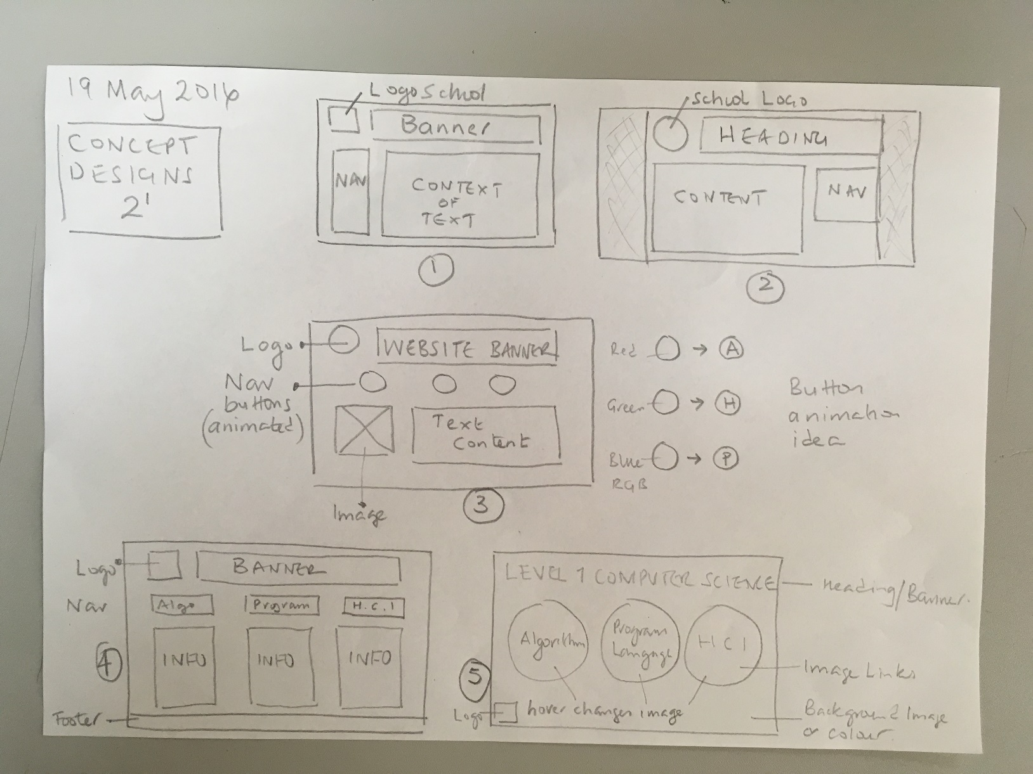

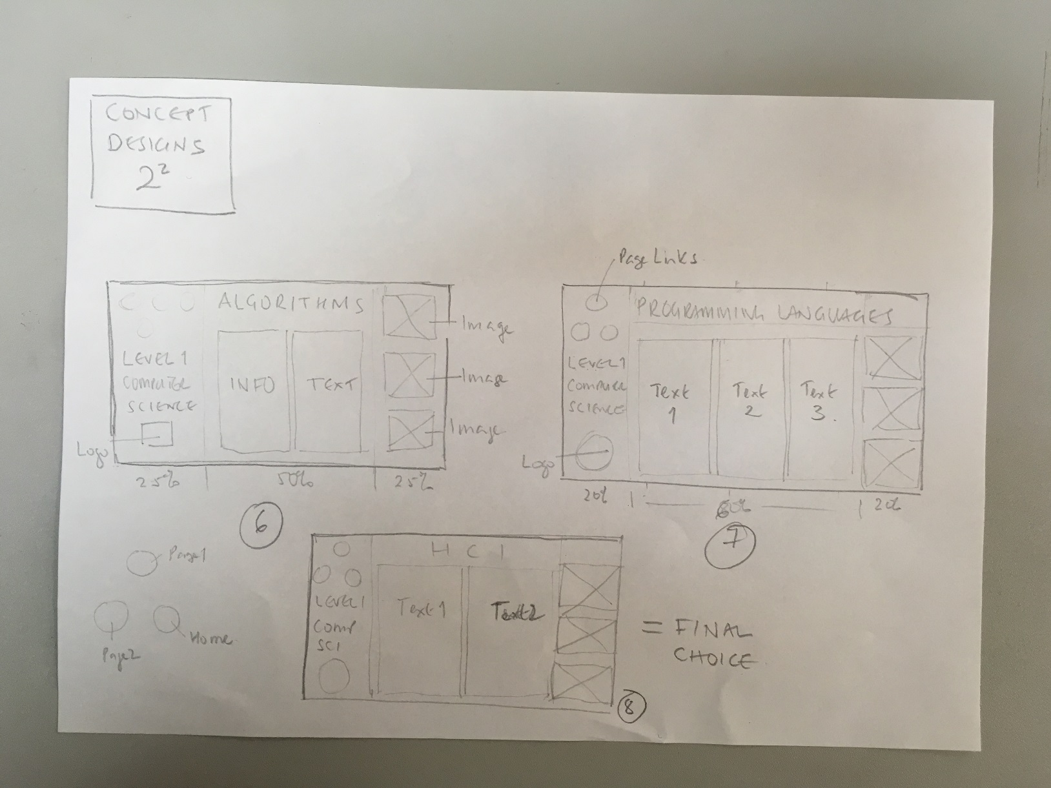

This sketch shows 3 more layout options for a proposed website.

So 8 in total.

Final Concept Design DECISION MADE AS A RESULT OF MEETING 2

|  |  |  |
| --- | --- | --- |
| CHOSEN LAYOUT | STAKEHOLDER COMMENTS | DECISIONS AS A RESULT OF CHOICE |
| Layout x | Make objective comments on the reason and justification for the layout the stakeholder liked (or not), from any website. | Make comment on any decisions that are made at the meeting regarding the layout.  You should comment as to why the chosen layout was preferred. Try to reference this against the CARP principles. |

**FINAL DESIGN SKETCH**

The sketch below shows the FINAL choice of design for the proposed website.

It meets the needs of the stakeholder, as decided at Meeting 2.

NOTE – YOU CANNOT DO THIS BEFORE THE MEETING!!

It is now ready for the wire framing to be completed.

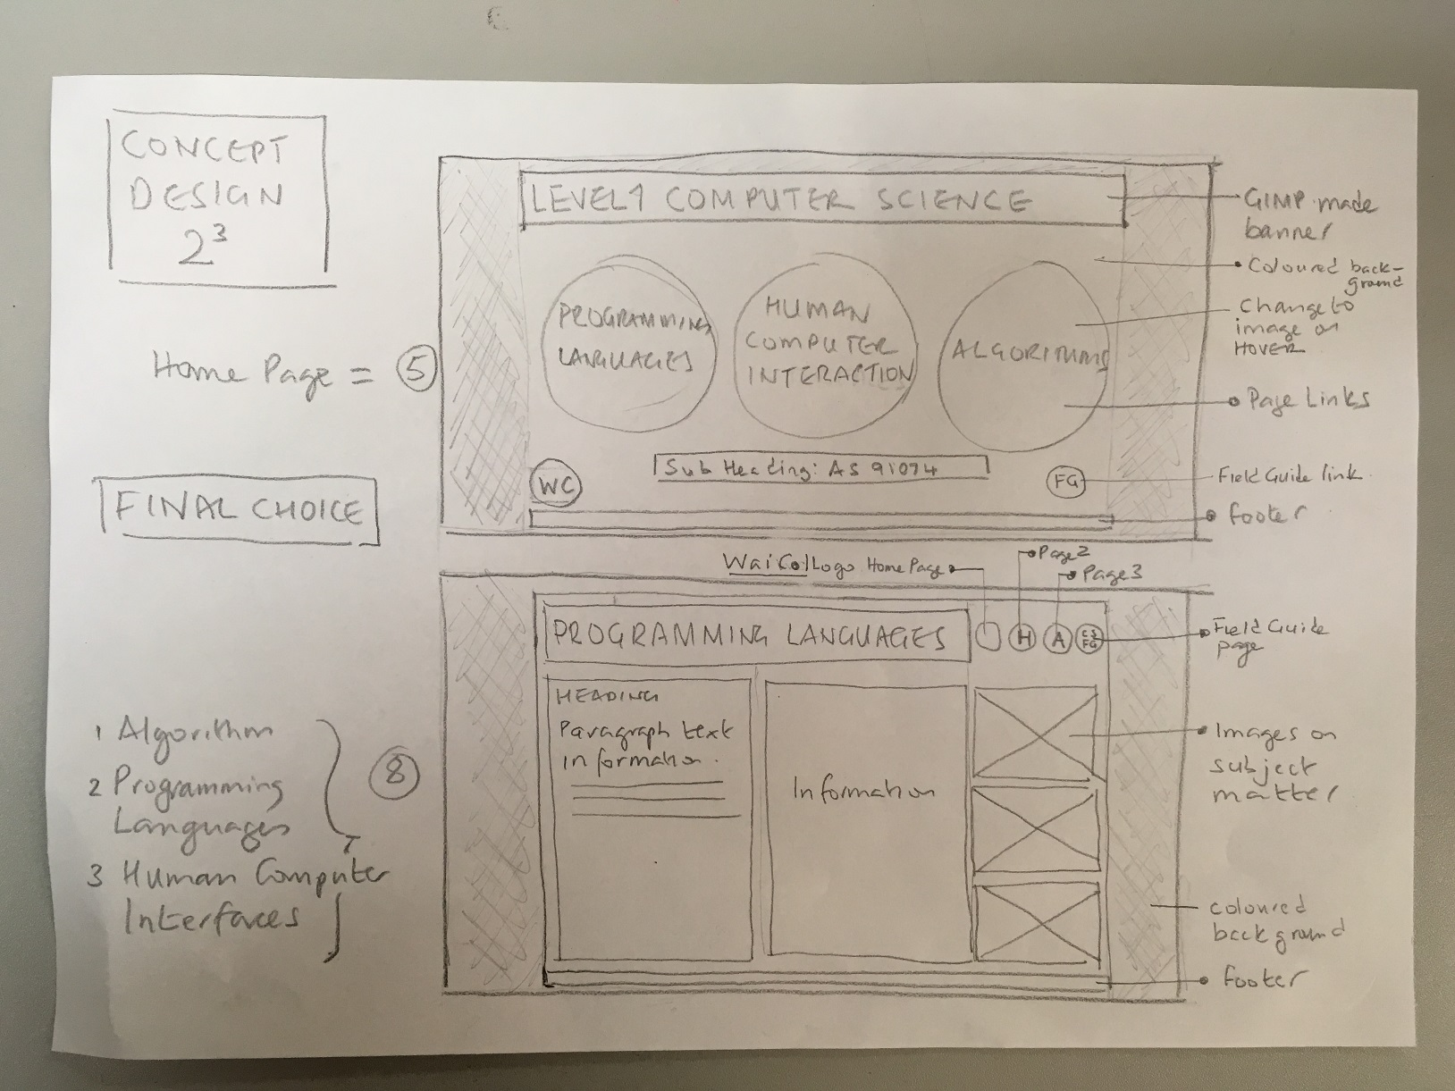

DELETE ALL OF THESE IMAGES AND INSERT YOUR OWN FROM THE PHOTOS YOU TOOK OF YOUR CONCEPT DESIGN LAYOUTS

DELETE ALL THE ABOVE GREY TEXT WHEN YOU MAKE YOUR OWN COMMENTS.

NOTE THAT YOUR COMMENTS SHOULD BE VERY SIMILAR TO THOSE GIVEN IN THIS EXAMPLE.

ANNOTATE THE IMAGES FOR CLARITY IF NEED BE.

STAKEHOLDER MEETING 2

MEETING DATE: 10 March 2016

STAKEHOLDER: Adam Smith + Sue Foo

Questions and decisions regarding aspects such as font, layout, colour images etc have been documented in the above pages.

|  |  |  |
| --- | --- | --- |
| **PHYSICAL ATTRIBUTES** | | |
| **ATTRIBUTE** | **STAKEHOLDER NEEDS** | **DEVELOPER DECISIONS** |
| Website should be ‘clean and green’. | Ensure the colour scheme makes use of light colours and that the font contrast is sharp. All images should also be bright. | I used images that showed nature; flowers and colourful animals, in a bright blue sky. The colour scheme was yellow and green, in the main which gave it a clean appearance. The colours chosen made the audience feel calm, said the stakeholder. |
| Website Layout | Layouts are not suitable. Want to see another set of ideas. | I will draft another five design concepts, making use of the attributes that the client is currently pleased with.  The new designs will have either - less content and smaller images sizes to allow for the spacing he is looking for – or larger images with less textural content in one block. |
| Site colour | Adam requires a more punchy background colour that makes the text stand out better than it does in the final concept design. | I will investigate colour contrasts with fonts. Plus, I will research for a font that has an appealing, fun look to it. |
|  |  |  |
| The principles of CARP adhered to | Use the colours of the club team. | REPETITION was achieved by choosing a colour swatch that used the club colours. These were used on each page, ensuring the background, fonts and shading were consistent on every page. |
|  |  |  |
|  |  |  |

|  |  |  |
| --- | --- | --- |
| **FUNCTIONAL ATTRIBUTES** | | |
| **ATTRIBUTE** | **STAKEHOLDER NEEDS** | **DEVELOPER DECISIONS** |
| Responsive | I would like my website to be able to be viewed on all devices | I will need to include media queries and ensure images are saved for small, medium and large displays. |
| Video link | Requires a link to his Playlist on YouTube | I need to create a YouTube account, establish a Playlist and upload video content. Client will provide the video content. |
| Video content | A video of the basketball team should be included | I will attend a basketball game and training take a video and add text and music to it. I will do this on YouTube and get back to Simon to see if he approves. |
|  |  |  |
|  |  |  |
|  |  |  |

DELETE THE ABOVE GREY TEXT WHEN YOU MAKE YOUR OWN COMMENTS.

STAKEHOLDER MEETING 3

MEETING DATE: 10 February 2016

STAKEHOLDER: Adam Smith + Sue Foo

PURPOSE:

1. Present the finalised conceptual design via the completed wireframes of each page.
2. Discuss the suitability of the conceptual design with regard to the Attributes (stakeholder’s specific needs), established at Meeting 2.
3. Decide upon any further changes that are required
4. Sign off job if all is good.

DECISIONS MADE AS A RESULT OF MEETING 3

IT COULD WELL BE THAT THERE IS NO NEED FOR FURTHER DEVELOPMENT IF YOU GOT THINGS RIGHT WITH YOUR PLANNING AND THE STAKEHOLDER HAS NOT HAD A CHANGE OF MIND.

|  |  |
| --- | --- |
| **DEVELOPER QUESTIONS** | **STAKEHOLDER RESPONSE / NEEDS** |
| Are you satisfied with the final design choice?  If not why not. If so why so. | I’d be happy with this final concept as it answers my requirements.  It makes it easier to understand what the whole site is about.  The colours are acceptable s they match the shop front. |
| What could be changed and why | The images really do need to be bigger.  I want less text and larger images.  Remove the audio file that plays in the background as I think it is distracting. |
|  |  |
|  |  |
|  |  |

FITNESS FOR PURPOSE

**Fitness for purpose is used to judge whether the outcome serves its purpose in doing the job for which it was designed within its intended location.**

**This judgement is made against the brief.**

Think about it - if what you have designed is NOT going to answer what the stakeholder asked for in every detail, then it isn’t suitable; it isn’t fit.

If that’s the case, then just say that. **It’s ok to get it wrong,** believe it or not.

NASA send up rockets that explode a few kilometres from Earth – that wasn’t in the plan.

So, if necessary, you should state what is not correct, what didn’t work, why and what needs to be done to make it fit for the purpose it was designed for.

You’ve gone out of your way to ensure all is as requested, so your comments should reflect this.

To help make your commenting more objective, use the Conceptual Design Document and read the examples on the ‘Evaluating fitness for purpose’ section (page 21). Try to make comments like the examples in that section and make the words bold, like the examples to emphasise your justifying and evaluation arguments.

DELETE THIS LINE, THE ABOVE TABLE PLUS ALL OF THE REST BEFORE HANDING IN.

DELETE EVERYTHING IN GREY TEXT

KEEP EVERYTHING IN BLACK TEXT …..as some things have been done for you. Nice teacher eh ☺

Once you have deleted all the above, the Physical Attributes table on the next page will be the first thing on this page.

NOTE – Keep all pages in landscape please.

-------------------------

|  |  |  |
| --- | --- | --- |
| **PHYSICAL ATTRIBUTES** | | |
| **ATTRIBUTES** | **STAKEHOLDER NEEDS** | **DEVELOPER - HOW I MET THESE** |
| Website Features |  |  |
| Website Layout |  |  |
| Colour swatch |  |  |
| Fonts |  |  |
| Navigation |  |  |
| Textural Content |  |  |
| Website background |  |  |
| Images used |  |  |
| Readability |  |  |
| Legibility |  |  |
| Colour | The concept for the website should follow recognised media design principles. |  |
| Alignment | The concept for the website should follow recognised media design principles. |  |
| Repetition | The concept for the website should follow recognised media design principles. |  |
| Proximity | The concept for the website should follow recognised media design principles. |  |
| Something here | Something here |  |
| Something here |  |  |

|  |  |  |
| --- | --- | --- |
| **FUNCTIONAL ATTRIBUTES** | | |
| **ATTRIBUTES** | **STAKEHOLDER NEEDS** | **DEVELOPER - HOW I MET THESE** |
| Page Links | Links should work between all pages |  |
| Something here |  |  |
| Inclusion of a gallery of images | Ensure at least 20 images are used to portray a wide range of sports. | I took over 50 images of seven different sports and cultural activities. The client chose three for each sport/activity and was satisfied with the result. The 21 chosen images were used in the gallery. |
| Something here |  |  |
| Accessibility | Include one aspect of accessibility | All images have been given an alt tag with an appropriate description |
| Sustainability and Life Cycle | None specified | The website would need updating with fresh content as it came to hand and for as long as the site was required. |
| Maintenance | None specified | The website hosting and domain name would need to be paid for annually. A person needs to be appointed to do this and fund obtained to keep it live. |
| Cultural appropriateness | None specified | The Maori teacher at school would be asked to review the site for appropriateness. |
| Ethical testing | None stated | The target audience is open. All text and images have been read and seen by the stakeholder and approved as appropriate. |
| Copyright | The client wants to ensure all website content is of their own. | I created some of the images myself. Other were sourced from Google Images using the ‘labelled for non-commercial reuse’ statement.  All text was of my own. |
| Something here |  |  |
| Something here |  |  |

**MALFUNCTIONS**

List and discuss any aspects that didn’t work.

Date the time this occurred, what went wrong and how (if at all), you fixed it.

If these is none – just put ‘There were no malfunctions’.

**IMPROVEMENTS**

Here, list or comment on any improvement you feel you could make or DID actually make.

This is following the completed planning having had further thought for reflection after the final stakeholder meeting.

**STEP UP**

To elicit a higher mark, you should use a ‘new’ stakeholder that can evaluate the website for what it has been built for. For instance, you may have been using classmates or family to evaluate a school cultural website but one of the ‘wider stakeholders’ would be the staff at the school.

So why not approach a teacher and ask them about the website as this gives authenticity.

Additionally, if it is a gaming website, a focus group of several students who game would provide useful stakeholder feedback.

**REFERENCES**

List all references used – if any, that you might not have already referenced. Usually websites, but also books or magazines or people.

~~ END OF ASSIGNMENT ~~